UNIVERSITY OF CAPE TOWN | CSC2001F
Hash Tables

ANELE CHILA | CHLANE001
PROBLEM DESCRIPTION
Given an Electronic telephone directory we are to create an application that uses 4 hash functions to generate hash values for each key (full name) in the directory. We then conduct an experiment to test how well a function generates unique and dispersed values. We are to use the information-theoretic notion of entropy that calculates the information content of a random variable. The hash function is the random variable. A higher entropy is better.
A hash function is function that maps items into small indexes, these indexes are called hash values.
Entropy is an expected value of the average information content or measure of the unpredictability of the state. Content would refer to the number of times the same hash value appears and unpredictability is associated with the probability.

Application design and correct implementation
Using Buffered reader, first read the file containing 1000 names with details (Read the file until end of file is reached). Then use string manipulations to acquire full name only. Each full name is now used as key. Hash each key (use a hash function to generate an integer value that represents an index). The hash value returned needs to be checked if it is greater than zero since an index cannot be less than zero. A set of four hash functions are generated (i.e. hashWorst, Hash1, Hash2, hash3).

-HashWorst:
This function hashes key (the full name) in the worst case. This is the case were all keys have been assigned the same hash value.

-Hash1:
This function adds the Unicode values of character in the key and then hashes that sum by taking the modulus ( hashValue = sum % tablesize).

-Hash2:
This function adds the shifted Unicode values of character in the key and then hashes that sum by modulo tablesize . For uniqueness in avoiding collisions, each character is shifted by 37. This also increases hash value.

-Hash3
This function adds the shifted Unicode values of character in the key and then hashes that sum by modulo table size. For uniqueness in avoiding collisions, each character is shifted by 37. This also increases hash value .If hash value generated is negative, the hash value is added to the table size. The sum becomes the new hash value. This is to cater for negative values.
When running a function, the hash values are then stored in an array, call it array 1. From this array1, count the number of times an item (a hash value) has been repeated. For the current item being counted store it in an array, say arrayCONTROL. For counting for the number of times the next item has been repeated, first check if the item is not in arrayCONTROL (so that you do not double check the same item/value in cases of duplicated items). For each count done, store the count in a new array (say array2) in an index equal to the hash value. Do this until all values are counted.
The probability of a hash value will just be calculated by accessing the count value in the index equal to the hash value then dividing by 1000 the number of words.
Then entropy will be calculated by the the formula –P(x) log (P(x)) for each key then sum the values generated.
Additional information:
NullPointerException:
When readLine tries to read beyond the end of a file, it returns the value null and my code will try to hash this key. This of course will produce a null pointer exception error at runtime .Hence my code hash null pointer handling using if statements . It does this by ignoring the key and returning Zero if key is null .

Scanner class and Output:
When the code is ran it asks for the hash function to be executed using Scanner class. User then enters function from list provided. Program will then execute a table containing hashValue using string formating , entropy ,count (the number of duplicates for each hashValue) and probability .
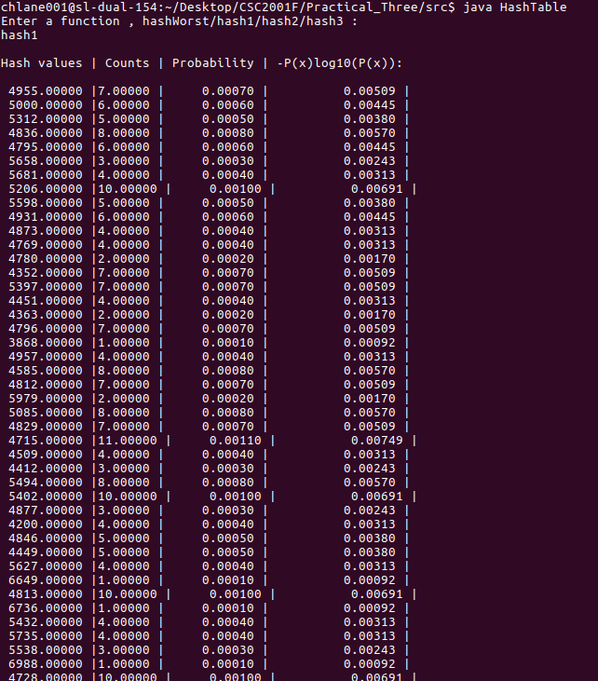
Hash function values reported Hash1
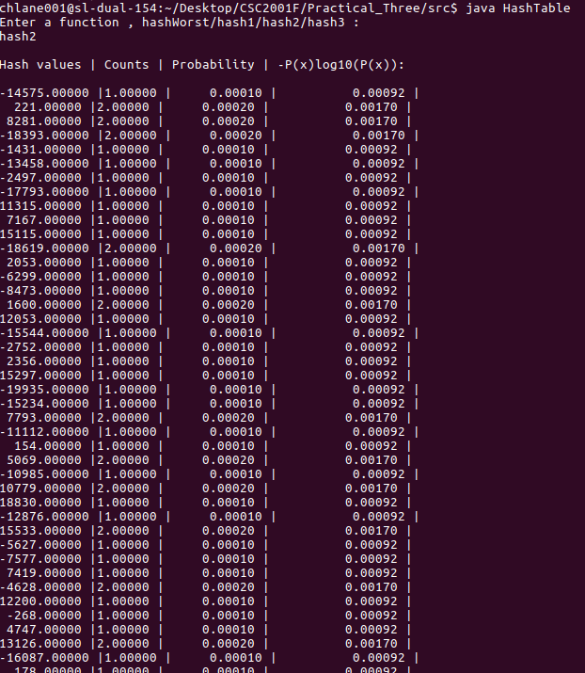
Hash2

Hash3
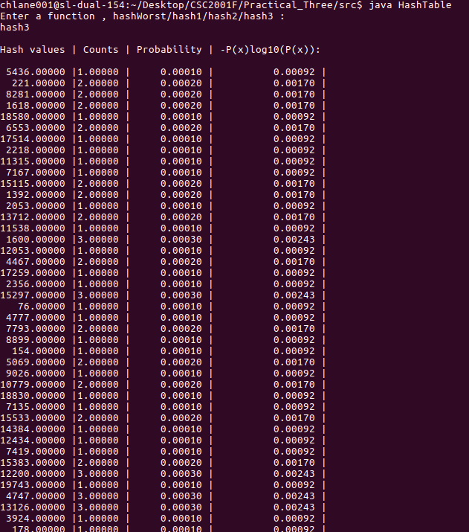

HashWorst
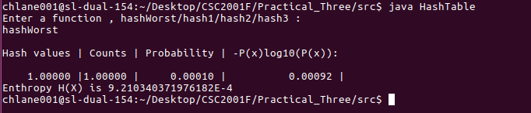

Experimental design
We would like to know how well a hash function generates unique and dispersed values . How does this function produce these unique and dispersed values.
We will put into use the information content of a random variable calculated by entropy. This will tell us how well a function hashes . The higher the entropy , the better the functioning and vice versa.

Hypothesis:
A hash function that adds shifted Unicode values will generate values which have less duplicates ,the function will have higher entropy .

A set of hash functions will be created to generate values. The frequency of each value will be used to calculate the Probability which in turn is used to calculate the the entropy of a hash functiooon. (Specific calculations are done by the Class file)

Results - tables and calculations
Tables have been provided in the Practical_Three directory as 4 files , hash1 (hash function one - to add Unicode values), hash2 (hash function two - to add shifted Unicode values), hash3 (hash function three - A reasonable function of my choice) and hashWorst (hash function in the worst case).
Calculations are provided as program Calculations. After hashing my keys, my program calculates count (frequency), probability, -P(x)log10(P(x)) and entropy and then prints out the output.

Discussion
Entropy values for hash1,hash2 and hash3 are 7.67, 9.05 and 8.9 respectively . These values might not be necessarily correct since my code had to cater for avoiding errors (in cases of division by zero and ‘key’ equal to null for end of file reading) and had to throw away some -negative hash values (discard them since they result in run time errors) which in turn affect my Entropy .
Entropy calculated by a code might come up with a lot of uncertainty since one may also want to fix collisions , this will affect the final answer of entropy. Avoiding collisions affect the hash value generated or sometimes the frequency.
Having considered some possible reasons to entropy being uncertain, it remains clear that the respective trend between the entropy values of the function is unaffected . Example, entropy of hash1 will always be less than entropy of hash2 since they are both affected in the same way and therefore both would experience the same effect. After all they are ran in the same application .

Conclusion
The hash function where unicode values are shifted(hash2) generates hash values best. I say this because of that it is has the largest entropy amongst the three.

